Quarterly report
  - Australian Small Business and Family Enterprise Ombudsman | Quarter 3 – 2016

Contents
Letter to the Minister
Foreword 1
Summary of recent key activities: 1
Outreach 2
Awareness & Education 2
Communications channels 3
Key meetings and events 4
Advocacy 5
Inquiries 5
Research and advocacy issues 6
Legislation, policies and practices impacting small business 6
Assistance 7
Examples of Assistance Provided 9

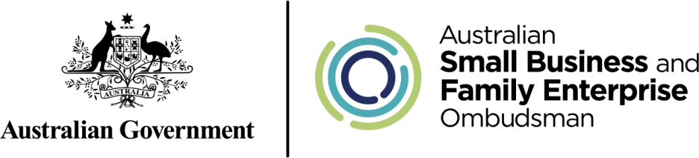

The Hon. Michael McCormack MP
Minister for Small Business

Friday 28 October, 2016

Dear Minister McCormack
Quarterly report
I am pleased to present you with this quarterly report outlining my outreach and advocacy activities, along with assistance requests from small businesses, during the period 1 July to 30 September 2016, in accordance with the reporting obligations outlined in section 40 of the Australian Small Business and Family Enterprise Ombudsman Act 2015 (Cth).
During this time we have concluded our first formal inquiry and commenced work on our second. Through our other advocacy activities, we have continued to contribute substantially to the formation and review of policy and legislation impacting on the small business and family enterprise sector.
The ASBFEO office has continued to provide many small businesses with guidance on a variety of issues, and I am confident the office is fast-becoming a reliable and valued source of information and assistance for the small business community.
I look forward to continuing to work with you and your office in order to create an environment that allows our small businesses and family enterprises to flourish well into the future.
Yours sincerely

Kate Carnell AO
Australian Small Business and Family Enterprise Ombudsman

Foreword
Legislation establishing the first small business and family enterprise ombudsman was introduced to Federal Parliament in 2015. The Australian Small Business and Family Enterprise Ombudsman (ASBFEO) Act 2015 subsequently received royal assent in September that same year.
Kate Carnell AO commenced the role of ASBFEO in March 2016. The role of the ASBFEO is to:
- Advocate for small businesses and family enterprises;
- Provide access to dispute resolution services to assist businesses in resolving disputes without resorting to costly litigation; and
- Ensure that Government policies take into account the needs of small businesses and family enterprises.

Summary of recent key activities:
This overview provides a brief summary of the ASBFEO’s activities throughout the third quarter of 2016.
- Outreach
  - Encouraging debate/consideration among small businesses and family enterprises on a range of issues relevant to their sector in order to shed light on matters impacting their livelihood.
  - Undertaking various media (metro, regional and rural) activity including radio, television and print interviews, social media activity, media releases and articles in trade publications.
  - Participating in meetings and events, while also delivering presentations.
- Advocacy
  - The report outlining the findings of the ASBFEO Inquiry into the impact of the Road Safety Remuneration Tribunal’s (RSRT) Payments Order on small businesses was presented to the Minister for Small Business, the Hon. Michael McCormack MP, and subsequently tabled in parliament.
  - Work commenced on the Small Business Loans Inquiry following a request from the Minister to investigate the adequacy of the law and practices governing authorised deposit taking institutions in lending to small businesses.
  - A range of advocacy activities were undertaken in relation to legislation, policies and practices that have an impact on small business. A number of submissions were put forward, including but not limited to proposed changes to superannuation laws, the ‘Backpacker tax’, and amendments to the Competition and Consumer Act in relation to section 46 (‘the effects test’).
- Assistance
  - The Ombudsman received close to 500 ‘contacts’ through phone and email.
  - The large majority of these were dispute-related enquiries or enquiries requiring general assistance or information.

Outreach

Awareness & Education
A range of issues were raised among the small business community, with the ASBFEO seeking consultation from and/or educating small business people on:
  - Succession planning;
  - Small business tax cuts (and other Budget-related measures);
  - Payment terms;
  - ATO & www.business.gov.au resources;
  - Mental health; and
  - Cyber security.
Following a formal period of consultation earlier in 2016 with the small business community, the ASBFEO is currently compiling a forward-work agenda that reflects the key issues small business and family enterprises are facing. This work program will be released in the near future.

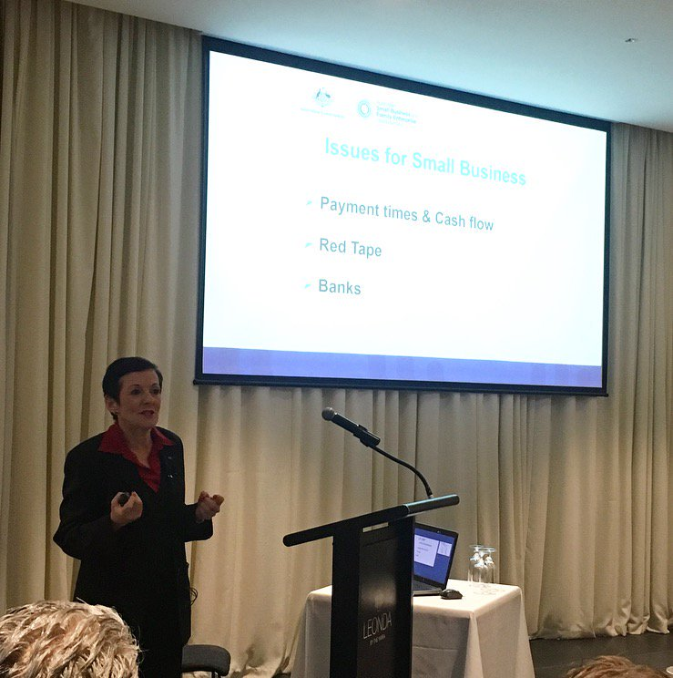
Australian Small Business and Family Enterprise Ombudsman Kate Carnell discussing issues facing small business at an event hosted by MGA Independent Retailers.

Communications channels
During the reporting period, the Ombudsman undertook various media (metro, regional and rural) activity including radio, television and print interviews, social media activity, media releases and articles in trade publications.

Website
During the reporting period there were more than 11,000 hits on the ASBFEO website. The breakdown below illustrates that the majority of those hits were new visitors.

News Subscriptions
As at 30 September 2016, 1,172 people had subscribed to receive news updates and newsletters though the ASBFEO website.

Social media
As at 30 September 2016, the Ombudsman had 250 Twitter followers, up from 152 in the previous quarter. The ASBFEO is also engaging with the small business community through Facebook and LinkedIn.

Media Releases
The ASBFEO published the following media releases/columns between 1 July to 30 September, 2016.
- 1/7 – Don’t get caught out online
- 8/7 – Small biz focus in SA Budget
- 11/7 – It’s never too late to seek help
- 18/7 – Getting down to (small) business with the new minister
- 21/7 – Column: No jokes, the taxman’s here to help
- 28/7 – Late payments can trigger an early demise
- 12/8 – Subbies safeguards a positive step
- 24/8 – Less talk and more action needed on banks
- 31/8 – Ombudsman to use Royal Commission powers to probe banks
- 1/9 – Small businesses counting on tax cut
- 5/9 – ‘Effects test’ vital for small businesses
- 8/9 – Column: Banking inquiry gives ombudsman a chance to examine small business hardships
- 15/9 – RSRT Payments Order stressful and discriminatory towards owner-drivers
- 19/9 – Succession planning in the ‘too-hard’ basket
- 21/9 – Column: Small business a unifying force in the Senate
- 27/9 – Certainty restored for small business seasonal workforce

Key meetings and events
The Ombudsman held a range of meetings in recent months with small business owners, industry associations as well as small business representatives within the Commonwealth and State Governments.
The Ombudsman also took part in a range of speaking engagements including but not limited to:
- Bondi Chamber of Commerce;
- Cairns Chamber of Commerce;
- MGA Independent Retailers Breakfast;
- Opening of the Family Business Australia (FBA) Conference;
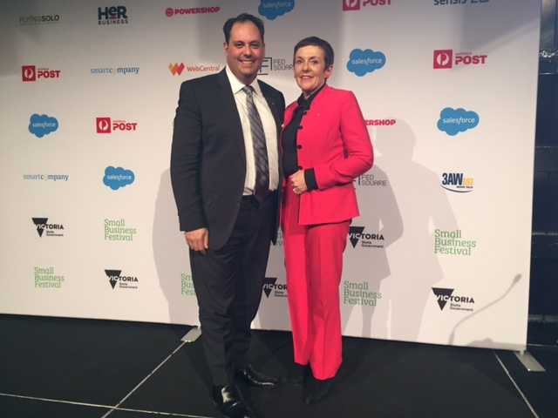
- ATO Business Digital Showcase;
- COSBOA National Small Business Summit;
- Victorian Small Business Festival Launch;
- Victorian Bus Association Expo.
Australian Small Business and Family Enterprise Ombudsman Kate Carnell with Victorian Small Business Minister the Hon. Philip Dalidakis MP at the launch of the Victorian Small Business Festival.

Advocacy

Inquiries

Road Safety Remuneration Tribunal (RSRT)

The Ombudsman completed an inquiry into the effect of the Road Safety Remuneration Tribunal’s (RSRT) Payments Order on small businesses and family enterprises. The inquiry also investigated ways in which Government can improve how it consults with the small business sector, during the development of future tribunals.

The final report was presented to Small Business Minister, the Hon. Michael McCormack MP and subsequently tabled in parliament on 14 September, 2016.

Key findings:

  - The Payments Order resulted in owner drivers in the long distance and supermarket distribution sectors being made uncompetitive. This exacerbated the competitive pressures already faced by owner drivers.
  - There was significant uncertainty and anxiety for owner drivers (and others involved in the industry) about the application and impact of the Payments Order given its complexity and short implementation time.
  - Uncertainty for owner drivers continues beyond abolition of the Tribunal and the Payments Order.
  - The effect of the Payments Order on individual owner drivers and small businesses was significant, with financial hardship and stress placed on personal relationships and mental and physical health.
  - The Payments Order was discriminatory in its application to owner drivers and small family businesses and this discrimination was not based on a sound and sufficient evidence base.
  - The Tribunal’s processes were adversarial and overly legalistic with an absence of flexibility extended to owner drivers to accommodate their lack of legal representation and limited understanding of tribunal and court-like processes.

Small Business Loans Inquiry

The Ombudsman has been requested by the Minister for Small Business, the Hon Michael McCormack MP, under section 42(1) of the Australian Small Business and Family Enterprise Ombudsman Act 2015, to undertake an inquiry into the adequacy of the law and practices governing authorised deposit taking institutions in lending to small business.

The Ombudsman’s Inquiry will review a selection of the cases identified by the Parliamentary Joint Committee (PJC) on Corporations and Financial Services in its report, The Impairment of Customer Loans, as unfair, and pursuant to the terms of reference, will provide advice to Government to help determine if the issues in those cases are now being addressed by current Government and industry reforms, or if additional reform measures should be implemented.

The interim findings of the Ombudsman’s inquiry will be provided to the Ramsay Review, to inform its wider review of resolution schemes.

Payment Terms Inquiry

The Ombudsman is undertaking preliminary work on a future inquiry into payment terms. This inquiry will explore the effects late payments have on small businesses and family enterprises, and make recommendations on instigating and implementing best practice in this area.

Research and advocacy issues
The Ombudsman has focused on a range of policy areas the ASBFEO has identified as impacting upon small business and family enterprises. These include (but are not limited to):
- Competition and consumer issues: notably the commencement of the unfair contract terms legislation and the adoption of an “effects test” in relation to the misuse of market power
- Commonwealth procurement: The challenges for small businesses acting as sub-contractors on Government procurements
- Access to justice issues: ensuring small business concerns are accounted for in the Australian Consumer Law (ACL) review.
- Immigration: the issue of accessibility of the section 457 Visa program for small business
- Practice of banks: including de-risking for small business money remitters and associated challenges for small business
- Franchising challenges: across a range of sectors including retail food and motor vehicle issues.
- Personal Hire and securities: including following up on the proposed changes to the Personal Property Securities Act 2009 (Cth)

Forward work plan and Small Business Statistics
Work continued on a research report which provides relevant statistical information about the role of small businesses and family enterprises within the Australian economy.
The Ombudsman completed an extensive consultation process surrounding the development of a forward agenda for the Ombudsman’s advocacy work, which brought together a range of different views and comments from a large number of stakeholders within the small business community. In the quarter, the Ombudsman met with State Small Business Commissioners on the State and territory issues raised in this consultation. Both the forward work plan and the small business statistics will be made publicly available in the near future.

Legislation, policies and practices impacting small business
The Ombudsman participated in a variety of public inquiries and consultation processes involving a wide range of policy topics relevant to small businesses and family enterprises. The Ombudsman made over 13 submissions which commented on various regulatory proposals impacting on Australian small businesses and family enterprises, including (but not limited to):
  - Treasury’s superannuation reform package;
  - Treasury’s competition law amendments;
  - The Department of Agriculture’s Working Holiday Maker Visa review; and
  - Treasury Laws Amendment (Enterprise Tax Plan) Bill 2016.

Assistance
During the reporting period, the Ombudsman received 508 contacts through phone and email, the large majority of these being dispute related enquiries or enquiries requiring general assistance or information. . Figure 1 below represents a breakdown.

As seen in Figure 2 below, from the 248 dispute contacts that the Ombudsman received, the majority were in relation to business-to-business disputes.

Figure 3 below identifies who is contacting the Ombudsman – the majority of the contact is made by small business owners. The Ombudsman also received a number of consumer complaints that were referred to either the ACCC or the Fair Trading office in the relevant State.

Of the 508 phone and email contacts that were made to the Ombudsman during this reporting period, 36 per cent were referred to a Commonwealth or State Government Agency, 22 per cent were directed to a business advisory service and 24 per cent were referred to a State Small Business Commissioner as they were state based matters.
Figure 4

Examples of Assistance Provided

Small Business Loans Inquiry
The most common request for assistance received since the announcement of the Small Business Loans Inquiry is from small businesses that have lost their properties due to the bank foreclosing on their business loans. In these cases, the small businesses have used their homes or investment properties as a guarantee against their business loan. The banks undertake a re-evaluation of the properties which result in their worth being less than that of the loan amount, and force the small business owner into selling these properties in order to meet their financial obligation with the bank. We have also seen examples of where the bank has increased the interest rate of the business loan for no apparent reason, which puts the small business under financial stress.
Our office has provided assistance to these small business owners wherever possible, by corresponding with the banks and opening a dialogue between them and the small business. We are also using these cases to help inform our Inquiry with regard to the general behaviour of the banks.

Business-to-Business Disputes
Our office was recently approached by a small business located in Queensland who was in dispute with a larger national based business over payment. The dispute had been ongoing for over twelve months and the relationship between the parties had deteriorated significantly to the point where the larger business had ceased communicating with the small business and had commenced legal proceedings to recover the outstanding debt. The small business was very keen to resolve the matter and have an ongoing relationship with the larger business.
Our office was able to work with both parties and get them to agree to mediation prior to the trial date, which was organised through the Queensland Dispute Resolution Centre. We were subsequently contacted by the small business who informed us that they were contacted by the larger business prior to the mediation taking place and the matter was settled. The small business owner was very grateful for the assistance provided by our office – ‘if it was not for your effort we would not have had this outcome and to have solicitors working on a Sunday is a fantastic achievement. We definitely need people like you to help when we have genuine claims.’

Business to Government Disputes
As mentioned in the previous quarterly report, this office has been involved in discussions between the licensee of The Lobby Restaurant in Canberra and the landlord, the National Capital Authority (NCA). The relationship between the two parties has gradually broken down over the past 12 years and a recent decision by the NCA to not renew the licence after July 2018 has worsened the situation. The Ombudsman recommended that the NCA attend mediation with the licensee of The Lobby Restaurant, which was agreed to by both parties. Our office was in the process of organising the mediation, when both parties met and discussed the issues which resulted in a Deed of Release being signed.

