Quarterly report
  - Australian Small Business and Family Enterprise Ombudsman | Quarter 2 – 2016

Contents
Introduction 4
Reporting context 4
Summary of key activities during the reporting period 4
Outreach 5
Consultation on advocacy agenda 5
Communications channels 7
Website 7
News subscriptions 7
Social media 8
Media releases 8
Radio and TV interviews 9
Key meetings and events 9
Advocacy 4
Inquiries 4
Research 5
Legislation, policies and practices with an adverse impact on small business 6
Other advocacy functions 7
Contributions to inquiries into relevant legislation, policies and practices 7
Reviewing proposals relating to relevant legislation, policies and practices 7
Improving bankruptcy and insolvency laws 8
Assistance 8
Examples of Assistance Provided 11
Attachments 12
The Hon Michael McCormack
Minister for Small Business

25 July 2016

Dear Minister McCormack
Quarterly report
Congratulations on your recent appointment as the Minister for Small Business. This is a critical portfolio for the more than two million small businesses in Australia, and the 4.5 million people they employ.
I am very pleased to provide you with this quarterly report of my activities as the inaugural Australian Small Business and Family Enterprise Ombudsman. The report is designed to meet the advocacy reporting obligations outlined in section 40 of the Australian Small Business and Family Enterprise Ombudsman Act 2015 (Cth). The report also covers outreach activities being conducted by my Office, and statistics on requests for assistance from small business.
Having been appointed in March, this report covers my first substantive quarter in office. In this time we have continued to grow and establish the Ombudsman’s Office as an effective and well informed advocate and source of assistance for the small business and family enterprise sector. We commenced our first formal inquiry and have concluded a broad, formal period of consultation with the sector on their expectations of our office going forward. We have continued to be a ready source of help and information for small business through our outreach and assistance activities, and we are confident that the reach of our message is growing.
I look forward to working closely with you and your office.
Yours sincerely,

Kate Carnell AO
Australian Small Business and Family Enterprise Ombudsman

Introduction

Reporting context
The Australian Small Business and Family Enterprise Ombudsman formally came into being on 11 March 2016 with the commencement of the Australian Small Business and Family Enterprise Ombudsman Act 2015 (Cth) (Act).
The Act sets out quarterly reporting obligations relating to certain advocacy functions (see section 40). This quarterly report covers the period 1 April 2016 to 30 June 2016.
The Act requires the Ombudsman’s report to outline the following:
- Research and inquiries conducted under Division 2 of the Act; and
- Any relevant legislation, policies and practices which the Ombudsman believes are having an adverse impact on small business, and the reasons why the Ombudsman has formed that view.
In addition to the matters noted above, this report outlines ancillary activities that have been conducted by the Ombudsman during the reporting period with the aim of capturing all key activities of the office during the reporting period.

Summary of key activities during the reporting period
This report covers the following key areas and activities:
- Outreach activities, including
  - a formal period of consultation with the small business and family enterprise community on what they consider to be advocacy priorities for their sector (15 April – 30 June)
  - media activity including radio and television interviews, media releases and articles, and key meetings and events during the reporting period
- Advocacy activities, including
  - The undertaking of an inquiry into the Road Safety Remuneration Tribunal’s minimum payments order and the impact of this order on self-employed truck drivers
  - Continuing work on a research project looking at small business statistics with a view to collating a publication of statistics about small business
  - A range of ad hoc advocacy in relation to legislation, policies and practices that have an adverse impact on small business
  - Submissions to:
    - the ACCC on the issue of South Australian councils applying to conduct joint tendering for waste collection services
    - The Commonwealth Treasury on Government proposals to increase access to company losses, and improve bankruptcy and insolvency laws, as part of the National Innovation and Science Agenda
    - the Senate Economics Legislation Committee, in relation to their inquiry into anti-competitive conduct in the retail wine industry
    - the Productivity Commission, responding to their Draft Report on intellectual property arrangements
- Assistance activities, to provide an indication of the demand for the Ombudsman’s assistance services.
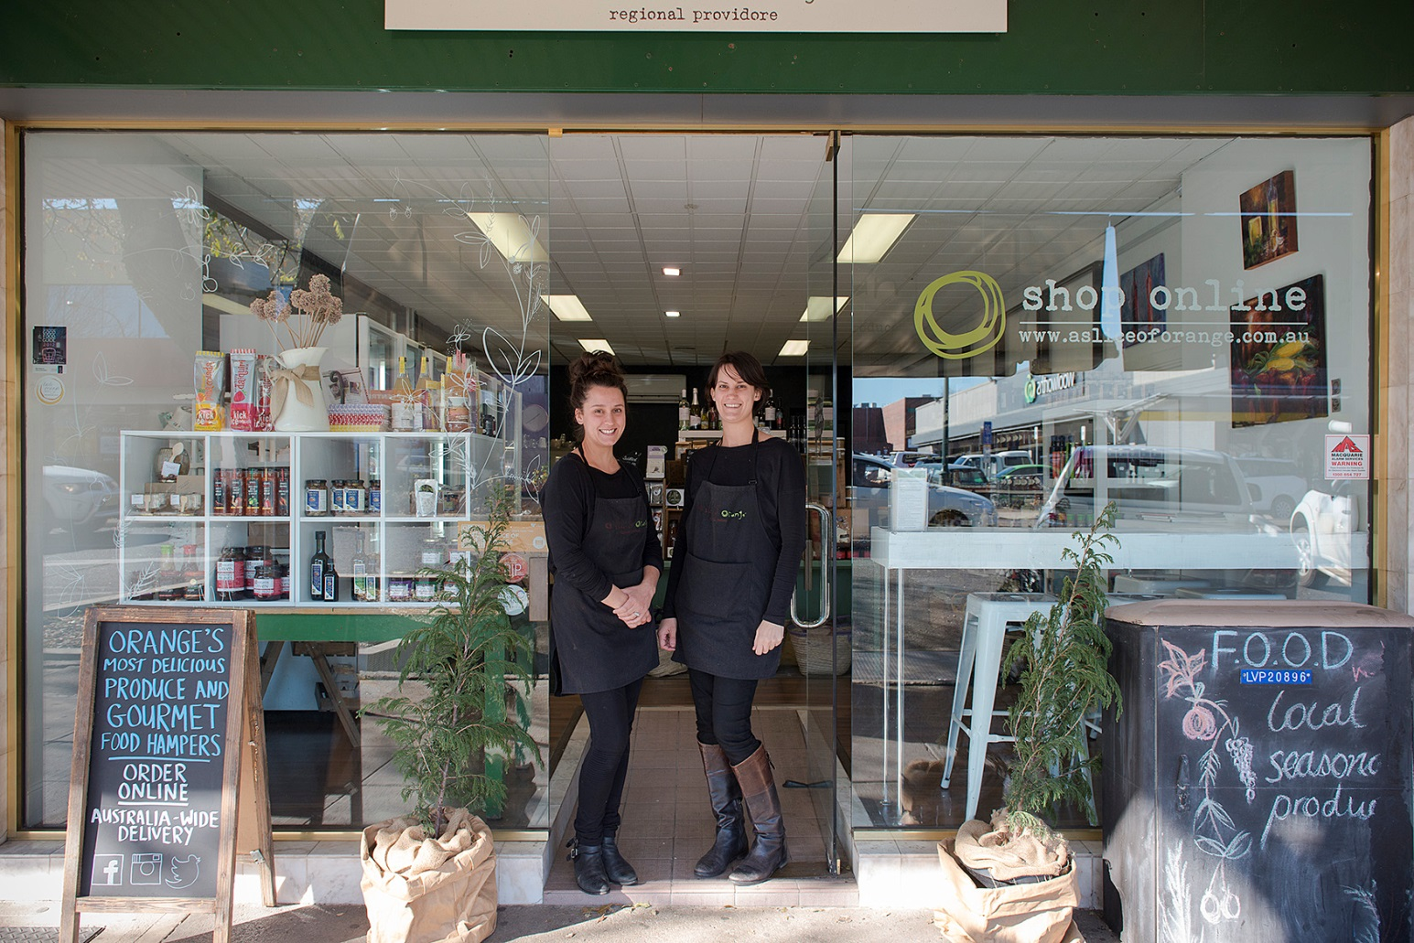

Outreach

Consultation on advocacy agenda
It is important that the advocacy work program of the Ombudsman’s Office is developed in consultation with small businesses and their representatives. A formal period of consultation was held from 15 April 2016 to 30 June 2016 to provide an opportunity to hear directly from small businesses and family enterprises about which issues they would like the Ombudsman to take up as their advocate.
During this time, the Ombudsman’s Office hosted and promoted an interactive online platform called thinkBIGsmallTALK, and encouraged small businesses and others to use this platform to discuss ideas about the use of our advocacy powers. We are keeping this platform open going forward so that emerging issues can continue to be easily raised with us and shared across the sector.
In addition to ideas posted to thinkBIGsmallTALK, the Ombudsman’s Office has received nearly 60 written submissions, and held a range of discussions and meetings across the country to ensure that we have captured a wide range of perspectives on the key challenges facing small business.
The Ombudsman’s Office is currently considering the issues raised during the consultation period with a view to developing a public-facing forward work agenda. The forward work agenda will flag key priorities for the office and is also likely to contain guiding principles which will inform other advocacy work such as contributions to other inquiries or reviews being held across government.

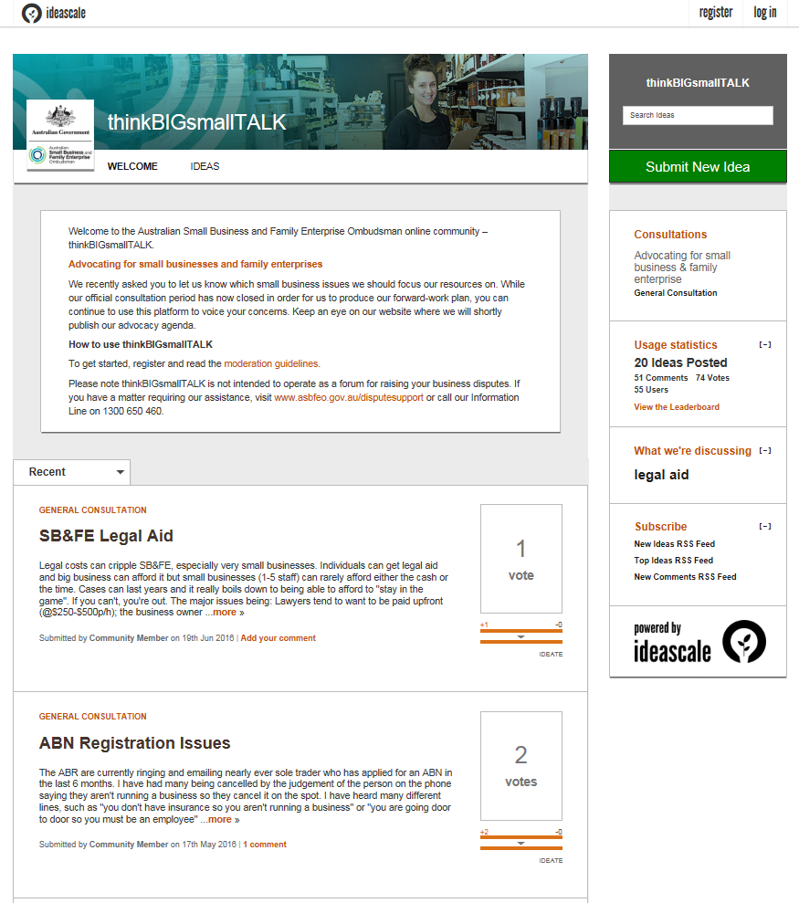

Some of the key themes emerging from this consultation include:
- The impact of power imbalances between large and small businesses – for example the issue of lengthy payment terms for small business suppliers
- Unfair competition – for example imported goods that do not comply with Australian safety standards competing against compliant domestically-manufactured goods
- The need to improve interactions with government – including effective access for small and regional businesses to procurement opportunities
- Red tape – with a particular focus on the taxation and workplace relations systems
- Concerns about telecommunications infrastructure – for example the inability to access landline and broadband for business premises
We look forward to discussing the outcomes of the consultation with you further in the context of developing our forward work plan and advocacy agenda.

Communications channels
To coincide with the commencement of the Office, the Ombudsman established a number of communications channels. These channels are being used to promote awareness of the Ombudsman among the small business and family enterprise sector, and as platforms for advocating for and engaging with small business and family enterprise.

Website
The Australian Small Business and Family Enterprise Ombudsman’s website was launched on 11 March 2016. As at 30 June 2016, the website had 6,830 visitors.
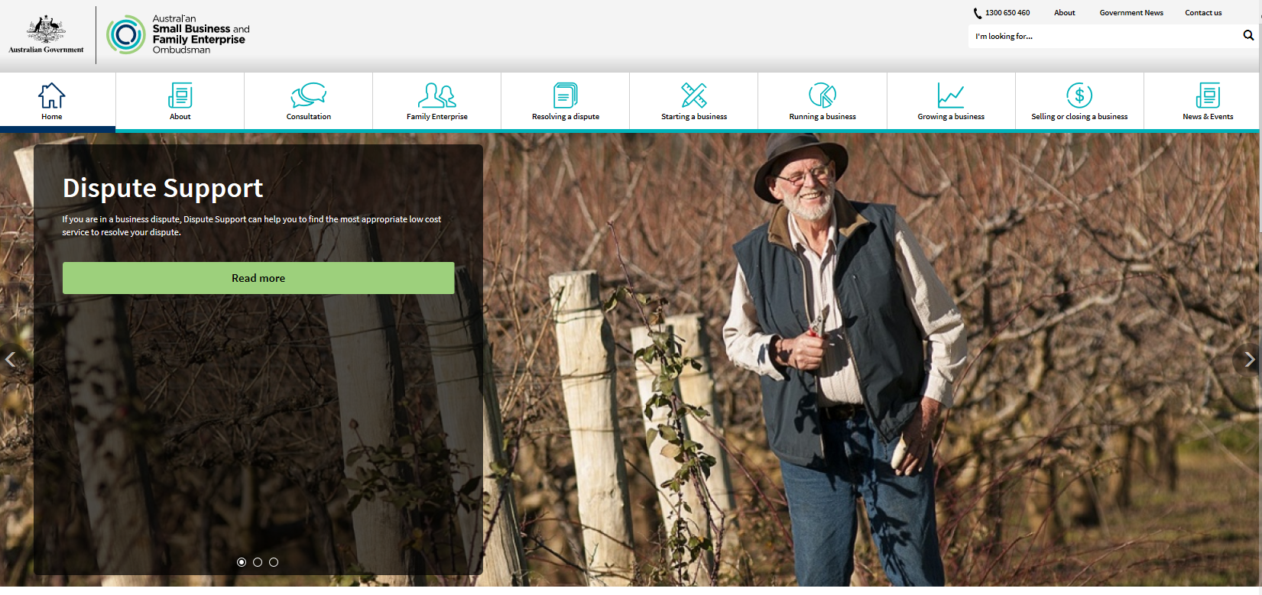

News subscriptions
As at 30 June 2016, 1072 people had subscribed to receive news updates and newsletters through the Ombudsman’s website.

Social media
As at 30 June 2016, the Ombudsman had 152 Twitter followers and had posted 174 tweets.
The Ombudsman’s Facebook and LinkedIn pages are in their infancy stage.

Media releases
The Australian Small Business and Family Enterprise Ombudsman published the following media releases between 1 April to 30 June 2016:
- 1/4: Upwards of 70,000 small businesses’ livelihoods under threat
- 4/4: Small business given last minute reprieve
- 13/4: Scrap RSRT to restore small business confidence
- 15/4: New online platform to share big ideas from small business owners
- 19/4: Confidence restored for owner-drivers
- 21/4: Small businesses warned against cyber threats
- 27/4: MySmallBusiness column: Big business and government need to pay small businesses on time
- 3/5: It’s never been a more exciting time to be an SME
- 5/5: The budget puts the nation back in business
- 9/5: ASBFEO to examine RSRT impact
- 16/5: Roundtable first stop on road to payments order inquiry
- 26/5: Making the business case for mental health
- 26/5: Payment times a problem for productivity
- 30/5: ACT leading the way on payroll tax
- 1/6: RSRT payments order inquiry: owner-drivers invited to tell their story
- 9/6: RSRT payments order inquiry: community meetings underway
- 10/6: MySmallBusiness column: Seek help early for tax debt
- 10/6: TWU advert a disgrace
- 15/6: Qld budget supports small business innovation
- 17/6: Improving payment times in South Australia
- 21/6: Opening avenues for small business growth
- 24/6: Consultation deadline approaching
- 24/6: MySmallBusiness column: Beginners’ guide to exporting for small business
- 27/6: Another voice for small businesses in Qld
- 29/6: RSRT payments order inquiry: final call for submissions

Radio and TV interviews
The Ombudsman completed the following radio interviews between 1 April to 30 June 2016:

- 8/4: The Drum – general panel discussion
- 18/4: 6PR – ASBFEO consultation launch
- 19/4: 2GB – ASBFEO consultation launch
- 23/4: ABC News 24 ‘The Business’ – ASBFEO consultation launch
- 27/4: 3AW – ASBFEO consultation launch
- 29/4: ABC Darwin – ASBFEO consultation launch, RSRT inquiry
- 29/4: 104.1 Territory FM – ASBFEO consultation launch, RSRT inquiry
- 2/5: ABC 702 Drive – general panel discussion
- 3/5: 2GB – 2016 Federal Budget
- 4/5: Sky News – 2016 Federal Budget
- 4/5: ABC News Breakfast – 2016 Federal Budget
- 4/5: ABC NewsRadio – 2016 Federal Budget
- 10/5: ABC North West WA – RSRT inquiry
- 11/5: ABC Riverina – RSRT inquiry
- 16/5: Sky News – penalty rates
- 16/5: ABC 730 – penalty rates
- 19/5: ABC Wide Bay Bundaberg – ASBFEO, RSRT inquiry, Bundaberg Business Expo
- 19/5: Win News Bundaberg – Bundaberg Business Expo
- 21/5: Sunrise – penalty rates
- 30/5: ABC 666 Canberra – panel discussion
- 1/6: 2GB – RSRT inquiry
- 2/6: ABC Western Plains – RSRT inquiry
- 2/6: ABC Brisbane – internet access for small businesses
- 6/6: ABC Sth East SA – RSRT inquiry
- 8/6: 2CC panel discussion – 2016 ACT Budget
- 8/6: ABC Adelaide Mornings – RSRT inquiry
- 9/6: 6PR Breakfast – RSRT inquiry
- 14/6: 4GR Toowoomba – RSRT inquiry
- 15/6: ABC Southern Queensland – RSRT inquiry
- 16/6: 4WK Toowoomba – RSRT inquiry
- 20/06: ABC Goulburn Murray – RSRT inquiry
- 21/06: ABC Mildura-Swan Hill – RSRT inquiry
- 22/6: Star FM Shepparton – RSRT inquiry
- 28/6: ABC Northern Tasmania – RSRT inquiry
- 28/6: 2CC – ASBFEO consultations
- 29/6: ABC New England – RSRT inquiry
- 29/6: 7AD Devonport – RSRT inquiry

Key meetings and events
During the reporting period the Ombudsman held a range of meetings with representatives of key industry associations representing small business and family enterprise, and meetings with key small business representatives within the Commonwealth and State Governments.
The Ombudsman also completed the following speaking engagements:
- Roundtable discussion with Bunbury small businesses
- Speech at B2B Expos in Sydney and Melbourne
- Speech at the Bundaberg Business Expo
- Roundtable discussion with Bundaberg small businesses
- Speech at Beenleigh Yatala Chamber of Commerce event
- NSW Business Chamber breakfast and lunch events
- Speech at Burnie Business Expo

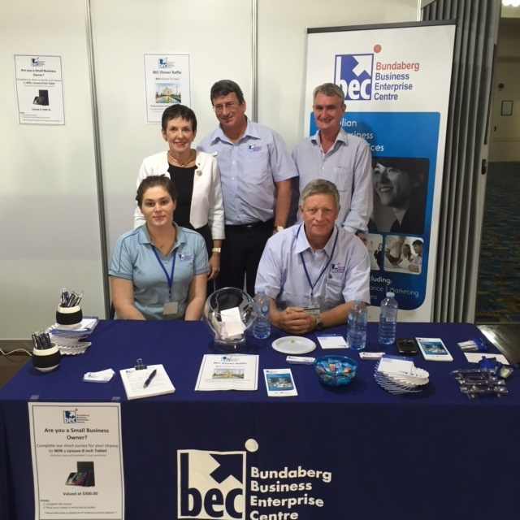

Advocacy

Inquiries

Road safety remuneration tribunal

In May this year we were asked by the former Minister for Small Business, the Hon Kelly O’Dwyer MP, to conduct an inquiry into the effect on Australian small businesses of the Road Safety Remuneration Tribunal’s Contractor Driver Minimum Payments Road Safety Remuneration Order 2016 (Payments Order). We were also asked to consider the ways in which the government can consult with small businesses in the development and operation of tribunals and other similar bodies.

This inquiry is the first formal inquiry conducted by our office and has been a key priority throughout the reporting period. The Ombudsman held an initial roundtable with key industry representatives followed by nine public consultations around the country, and received written and verbal submissions from stakeholders. A short online survey was also made available to assist with gathering information relevant to the inquiry.

Key themes presented that have emerged through the inquiry include:
- a number of businesses adjusted their practices to take into account the RSRT’s Payments Order by minimising their use of contractor drivers
- not all of these businesses reverted back to using contractor drivers, leaving some drivers with continued uncertainty and loss of work
- owner drivers had trouble understanding and applying the Payments Order
- many operators who had dealings with the RSRT say that it acted in an adversarial and non-neutral way, whilst their evidence was not given any weight
- there is support for mandatory minimum payment terms, such as the 30 day requirement in the first road safety remuneration order

Our Office is in the process of preparing a report for you on this inquiry for tabling in Parliament, which will include recommendations for the Government’s consideration.

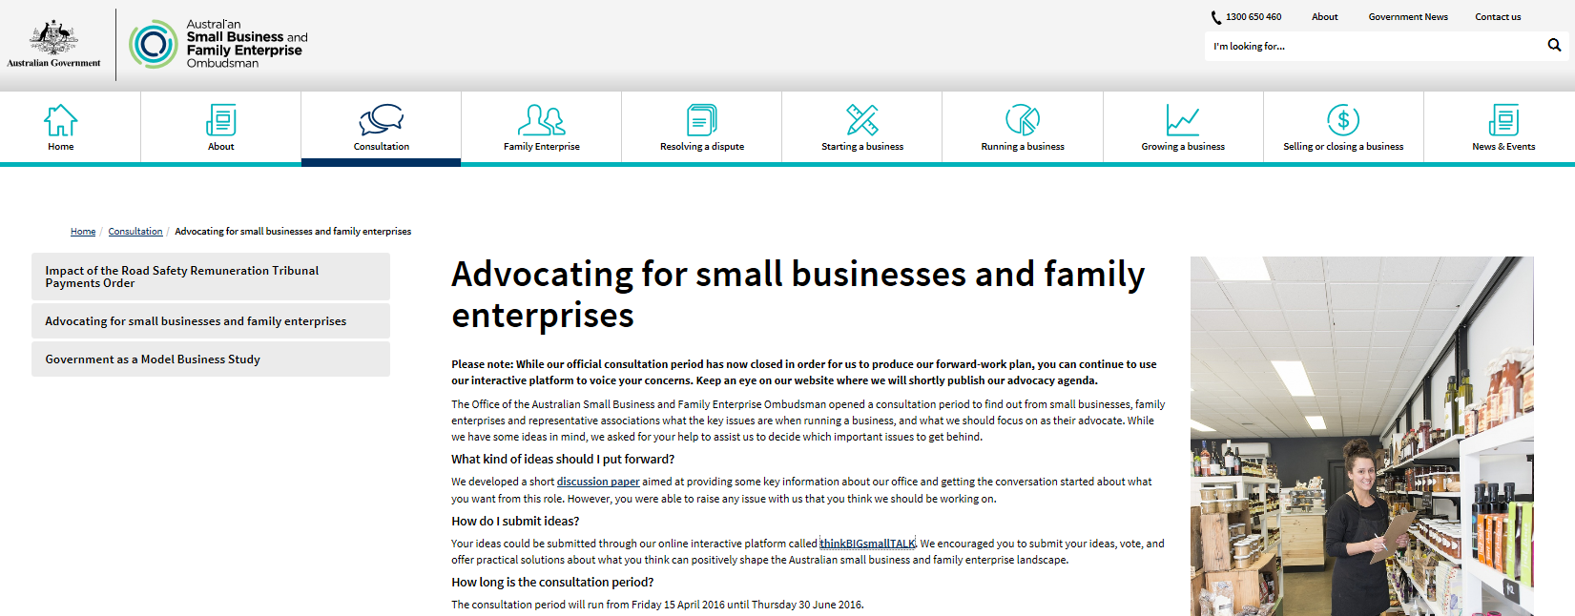

Research

Statistical research project
During the reporting period, work continued on a research project aimed at providing a statistical overview of small business in Australia. The Ombudsman intends to publish a report which will be a valuable resource for policy discussions involving small business and family enterprise. It is hoped that this report will be the first in a series of statistical overviews of small business to be released by the Ombudsman.
Further details on the outcomes of this research, including a copy of the final publication, will be included in future quarterly reports.

Legislation, policies and practices with an adverse impact on small business
As already noted, the Ombudsman’s Office has been conducting a broad consultation process to garner views from the small business community about the key challenges that they face, and areas where the Ombudsman could advocate for change.

One of the most compelling issues being put to the Ombudsman’s Office is the difficulty that small businesses often have in getting paid for the work they do for other businesses. Where a large business is setting lengthy standard payment terms for all their suppliers, there is little opportunity for negotiation and this has a negative impact on a small business’ cash flow, and in turn their viability. The Ombudsman has formed the view that this practice has an adverse impact on small business and family enterprise. The broad consultation process that has been conducted has confirmed the view that this is a broad issue for small businesses in multiple industry sectors. Whilst we are still formalising our forward work program, it is likely that this issue will be the subject of the Ombudsman’s first formal own-motion inquiry.

During the reporting period, we have also led a number of approaches to improve the impact of legislation, policies and practices on small business:
- Making representations to the Commonwealth Department of Education regarding red-tape in the approvals process for childcare businesses.
    - This issue was referred to us for consideration by the Office of the New South Wales Small Business Commissioner. Initial investigations indicate that there may be scope to simplify and improve the approvals process, including by requiring applications to be processed within a certain timeframe by the Commonwealth (we understand that at present there is no timeframe for approval to be provided, and lengthy processing times may cause state approvals to lapse before a business can be established).
- Making representations to Defence Housing Australia in relation to access for small businesses to procurement activities in regional and remote areas, including opportunities arising through sub-contracting arrangements with principal contractors.
    - We made these representations after speaking with a small business owner in a regional area experiencing difficulty in dealing with one of DHA’s prime contractors, who was not a local business. The subcontracted small business explained that local businesses had been unable to compete to be the prime contractor because of the scale of the procurement (which involved building multiple residential homes, and could have been broken up to improve opportunities).
- Engaging with the Australian Packaging Covenant (APC) and advocating for improved communications with small businesses coming within the remit of packaging regulation. We have also engaged with the Commonwealth Department of Environment who has a role in regulation to the APC and underlying regulatory framework.
    - This issue was referred to us for consideration by the Office of the New South Wales Small Business Commissioner. We understand that the style of APC communications is leading to confusion for businesses about their obligations under the associated regulatory framework.
- Making representations to the Australian Capital Territory Government in relation to concerns regarding the role of the UnionsACT body in ACT Government procurement.
    - This issue was raised with us by Master Builders ACT. We made representations to the ACT Government who provided a detailed response to those concerns. At this stage, no further advocacy is planned on this matter.

Other advocacy functions

Contributions to inquiries into relevant legislation, policies and practices

Waste collection in South Australia Authorisation application to the ACCC
The Ombudsman’s Office made representations to the Australian Competition and Consumer Commission in relation to an application by a group of councils in South Australia to jointly tender for waste collection services. Our Office provided a submission in support of the South Australian Small Business Commissioner’s submission expressing concern that authorisation of the joint tender process would inhibit the ability of small businesses in the region to tender for the work. As at the time of this report, no final decision has been made by the ACCC on this matter.
A copy of the Ombudsman’s submission is at Attachment 1.
Anti-competitive conduct in the retail wine industry
This submission was made to the Senate’s Standing Committee on Economics inquiry into anti-competitive conduct in the retail wine industry and the ACCC’s role. Our Office provided a submission highlighting the potential role of industry codes, the importance of reforms to misuse of market power laws, the impact of payment terms on participants in the industry, and the role of “own-brands” in the retail wine industry. This inquiry lapsed with the prorogation of Parliament on 9 May 2016 however our Office will continue to monitor any relevant outcomes when the Senate is reconvened.
A copy of the Ombudsman’s submission is at Attachment 2.
Intellectual property arrangements
The Productivity Commission is currently conducting a comprehensive inquiry into Australia’s intellectual property system. A draft report was released on 29 April 2016. Our Office made a submission responding to this draft report proposing improved accessibility and usability of the intellectual property system for small businesses. This included such measures as greater protection for small business from unjustified threats of infringement, cross-linking the business registration portal with the trade mark database, and establishing a system of protection for unregistered small business designs. The final report from the Productivity Commission is due to be released in August 2016.
A copy of the Ombudsman’s submission is at Attachment 3.

Reviewing proposals relating to relevant legislation, policies and practices

Access to company losses
On 7 December 2015, the Government announced a package of measures designed to incentivise and reward innovation as part of its National Innovation and Science Agenda. One of those measures will allow businesses that have changed ownership to access past year tax losses if they satisfy a similar business test. Under the current law, businesses that have changed ownership must satisfy the same business test to access past year tax losses. This measure will encourage entrepreneurship by allowing loss-making businesses to seek out new opportunities to return to profitability. The Ombudsman’s Office provided a submission in strong support of draft legislation established to implement this proposal. This legislation is expected to be put forward for passage through Parliament in the coming period.
A copy of the Ombudsman’s submission is at Attachment 4.

Improving bankruptcy and insolvency laws
As part of the National Innovation and Science Agenda, the Government has proposed to improve Australia’s bankruptcy and insolvency laws by making changes to the default bankruptcy period, introducing a safe harbour for directors, and changing the operation of ‘ipso facto’ clauses. The Ombudsman’s Office provided a submission in support of these proposals and how they may be designed to meet the needs of small business. Our Office understands that legislation is expected to be put forward to implement these measures in the coming period.
A copy of the Ombudsman’s submission is at Attachment 5.
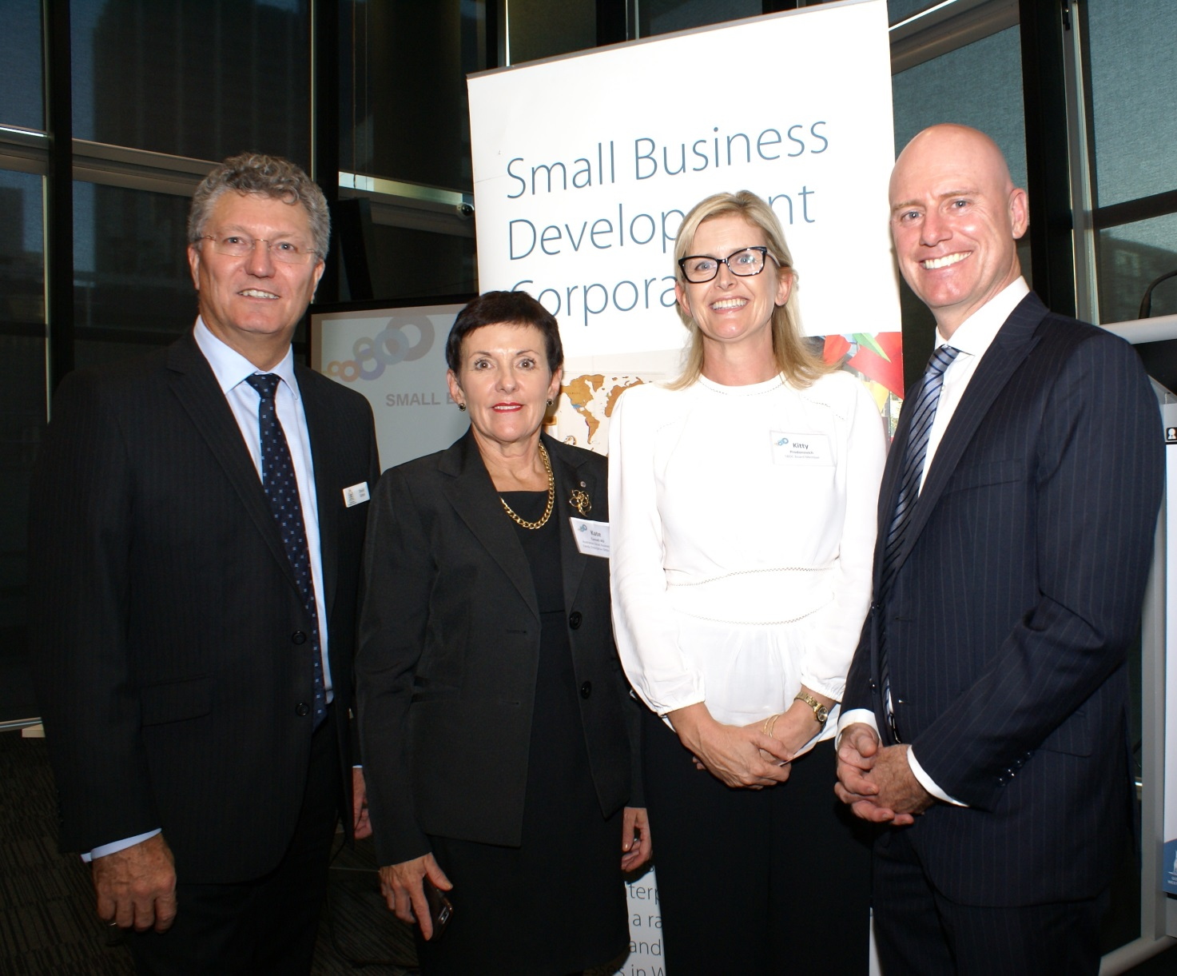
Australian Small Business and Family Enterprise Ombudsman Kate Carnell at a Small Business Development Corporation networking event in Perth in April, together with WA Small Business Development Corporation CEO David Eaton, Regional Chambers of Commerce and Industry WA CEO Kitty Prodonovich, and WA Small Business Minister Sean L'Estrange in Perth

Assistance
During the reporting period, the Ombudsman received 594 contacts through phone and email, the large majority of these being dispute related enquiries or enquiries requiring general assistance or information. During the inquiry into the Road Safety Remuneration Tribunal’s Contractor Driver Minimum Payments Road Safety Remuneration Order 2016, the Ombudsman’s office responded to relevant requests for assistance sought from owner drivers affected by the Order. Figure 1 represents a breakdown of the 594 contacts.
Figure 1

As will be seen in Figure 2, from the 301 dispute contacts that the Ombudsman received, the majority were in relation to business to business disputes.
Figure 2

Figure 3 identifies who is contacting the Ombudsman – the majority of the contact is made by small business owners. The Ombudsman also received a number of consumer complaints that were referred to either the ACCC or the Fair Trading office in the relevant State.

Figure 3

Of the 594 phone and email contacts that were made to the Ombudsman during this reporting period, 35 per cent were referred to a Commonwealth or State Government Agency, 24 per cent were resolved directly by our office and 21 per cent were referred to a State Small Business Commissioner as they were state based matters.
Figure 4

Examples of Assistance Provided

RSRT Payments Order
The most common request for assistance that was received during the inquiry into the Road Safety Remuneration Tribunal’s Contractor Driver Minimum Payments Road Safety Remuneration Order 2016 was from owner drivers who were struggling to meet their financial commitments. Our office contacted creditors, suppliers, banks and other financial institutions, encouraging leniency with small business owner-drivers who were attempting to recover financially as a result of lost work/contracts, and as such, loss of part or all of their family income.
Our office has been able to work with some of these groups that were willing to support their small business customers by providing assistance, such as, extension of time on payments and waiving late fees. This provided the small businesses with the time they required to improve their financial positions. However in some cases, the small businesses were deemed to be financially risky and therefore were not provided an extension of time. In other instances it was viewed that providing lending to these small businesses would be irresponsible, and that extending time periods to these customers would increase financial pressures, from which they would not recover.

Business to Business Dispute
Our office was recently approached by a small business located in Tasmania that did not receive their subsidy payment under the Restart Wage Subsidy and Tasmanian Jobs Programme. Due to a communication error between the small business and the employment group, the paperwork was not completed on time and they were not paid their subsidy. This not only resulted in a loss of $16,500 for the small business, but it has also put the long term employment viability for the new staff member at risk.
The ASBFEO contacted the Department of Employment to ascertain if they could assist or had the discretion to extend the cut-off date for the wage subsidy to be paid. As a result, the Department intervened and ensured that the small business was paid the wage subsidy and encouraged the employment group to consider a range of communication channels with employers to recognise the business demands on small business.

Business to Government Dispute
This office is currently involved in discussions between the licensee of The Lobby Restaurant in Canberra and the landlord, the National Capital Authority (NCA). The relationship between the two parties has gradually broken down over the past 12 years and a recent decision by the NCA to not renew the licence after July 2018 has worsened the situation. The Ombudsman has recently recommended that the NCA attend a mediation with the licensee of The Lobby Restaurant, in an attempt to resolve the current matters involving the maintenance and upkeep of the property, and to rebuild the relationship between the two parties. This should also assist with any further issues through to the expiration of the licence in July 2018.

Attachments
- Submission to the Australian Competition and Consumer Commission regarding the South Australian Council Solutions’ Application for Authorisation of a Combined Waste Tender Process (8 April 2016)
- Submission to the Commonwealth Treasury regarding draft legislation to increase access to company losses (14 April 2016)
- Submission to the Senate Economics Legislation Committee inquiry into anti-competitive conduct in the retail wine industry and the role of the Australian Competition and Consumer Commission (29 April 2016)
- Submission to the Commonwealth Treasury in response to Proposals Paper on Improving Bankruptcy and Insolvency Laws (25 May 2016)
- Submission to the Productivity Commission in response to their draft report on Intellectual Property Arrangements (9 June 2016)

